**Master Solution**

**LAB-2**

**Tasks:**

* Create a variable x that stores an integer. Use the sep optional argument to print out x, 2x, 3x, 4x, and 5x, each separated by three dashes, like below if x=7.

7---14---21---28---35

**Answer:**

x = 7

print(x,"---",2*x,"---",3*x,"---",4*x,"---",5*x)

* Given variables x and y, which refer to values 3 and 12.5, respectively, use function print() to print the following messages. When numbers appear in the messages, variables x and y should be used.
  1. The rabbit is 3.
  2. The rabbit is 3 years old.
  3. 12.5 is average.
  4. 12.5 * 3
  5. 12.5 * 3 is 37.5.

**Answer:**

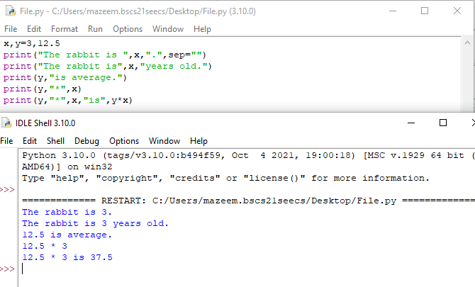

* For each of the following expressions, what value will the expression give? Verify your answers by typing the expressions into Python.

1. 9 - 3
2. 8 * 2.5
3. 9 / 2
4. 9 / -2
5. 9 // -2
6. 9 % 2
7. 9.0 % 2
8. 9 % 2.0
9. 9 % -2
10. -9 % 2
11. 9 / -2.0
12. 4 + 3 * 5
13. (4 + 3) * 5

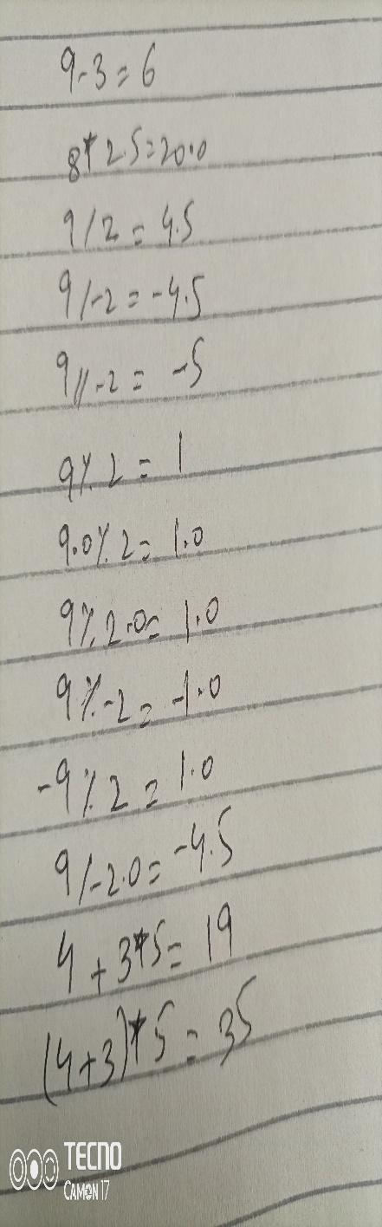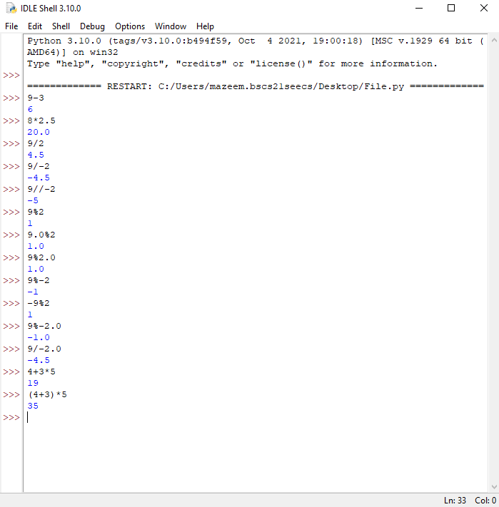

* Which of the following expressions results in SyntaxErrors? Identify the syntax SyntaxErrors and type the reason of error along with the correct code by mentioning its sequence number.

1. 6 * -----------8

No error:

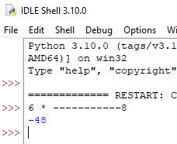

1. 8 = people

**Error: Name of variable cannot start with number or special characters except “_”**

**Correction: people=8**

1. ((((4 ** 3))))

No error:



1. (-(-(-(-5))))

No error:



1. 4 += 7 / 2

**Error: Actually “+=” is actually use for increment in a variable which is written on left hand side. But in the case, an integer is written that results in an error**

**Correction: a=4**

**a+=7/2**

* Using only the techniques you have learned so far, write a program that calculates the square and cube of the numbers from 0 to 10 and uses tabs to print the following table of values:

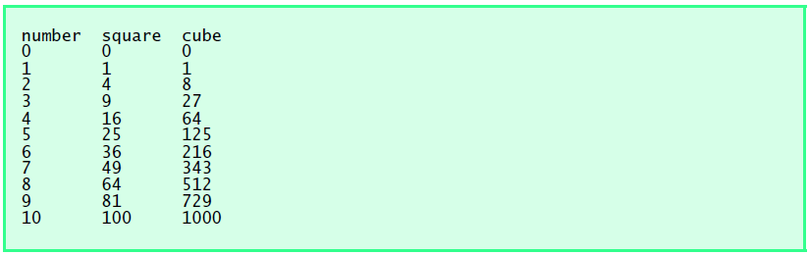

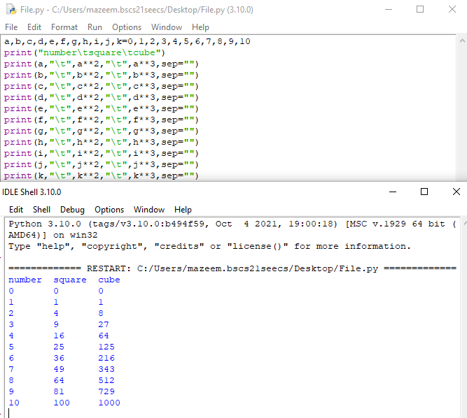

* Write a program that assign values to two variables and then swap their values.

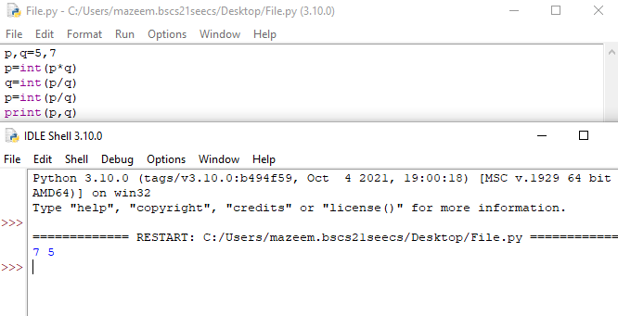

* Write a program that asks the user to enter two numbers, obtains the two numbers from the user and prints the sum, product, difference, quotient and remainder of the two numbers. Sample output is as following:

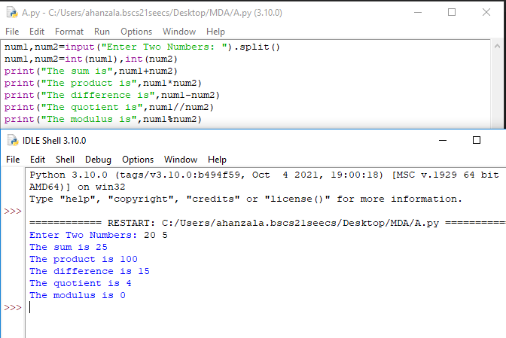

* Write a program that reads in the radius of a circle and prints the circle’s diameter, circumference and area. Use the constant value 3.14159 for π. Perform each of these calculations inside the print statement(s).

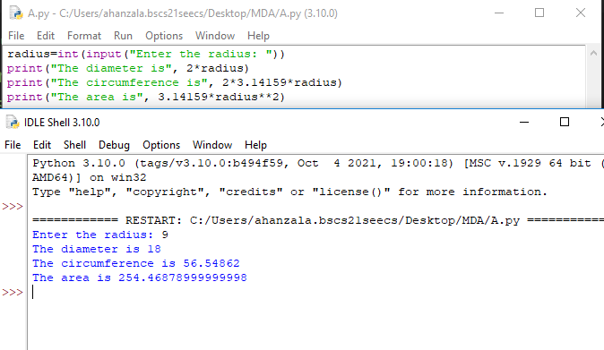

* Write a program that inputs one five-digit number, generates its reverse and displays the reverse on screen.

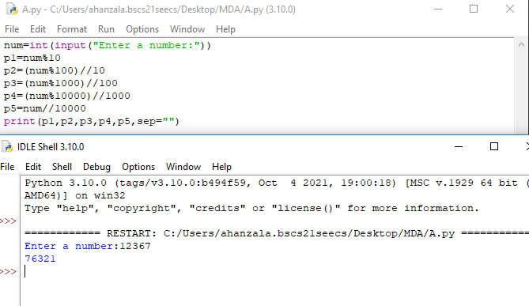

* Using whatever we have learned so far, write a program that prints a box, an oval, an arrow and a diamond as follows:

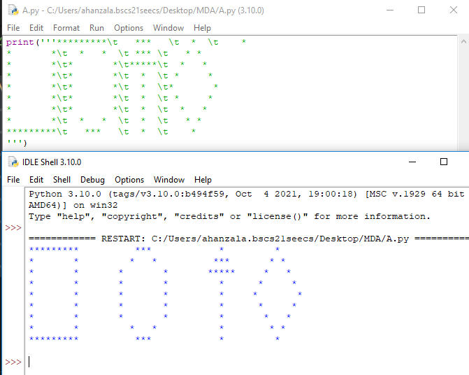

* Write a program that produces the following output:

HHHHHH

HHHHH

HHH

HH

H

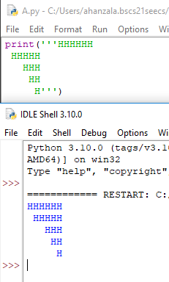

* Write a program that reads an integer and determines and prints whether it is odd or even.

* Write a program that inputs three different integers from the keyboard, and then prints the smallest and the largest of these numbers. **Use only the single-selection form of the *if statement*** that you learned in the class. The screen dialogue should appear as follows:

|  |
| --- |

* Write a program that reads in five integers and then determines and prints the largest and the smallest integers in the group.

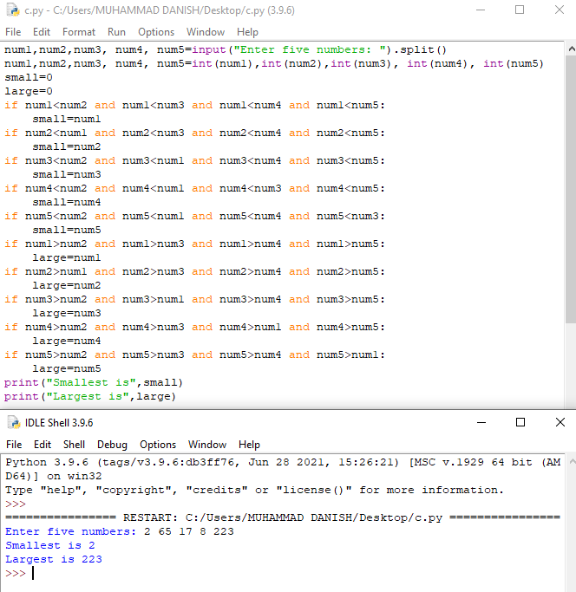

* Write a program that reads three nonzero integers and determines and prints if they could be the sides of a right triangle.

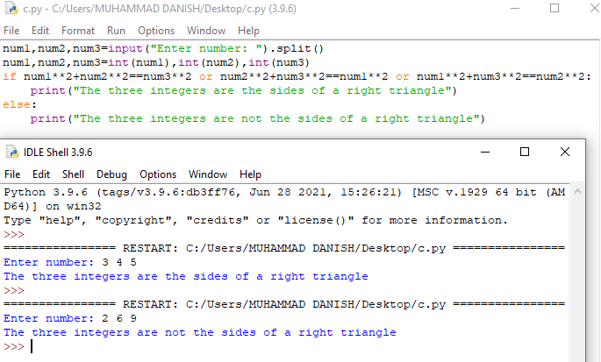

* A palindrome is a number or a text phrase that reads the same backwards as forwards. For example, each of the following five-digit integers are palindromes: 12321, 55555, 45554 and 11611. Write a program that reads in a five-digit integer and determines whether or not it is a palindrome.

* Write a program to prompt for a score between 0.0 and 1.0. If the score is out of range, print an error message. If the score is between 0.0 and 1.0, print a grade using the following table:

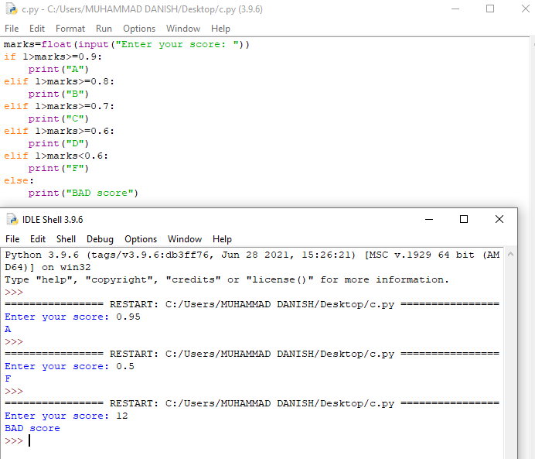

* Write a program that asks the user for an hour between 1 and 12, asks them to enter am or pm, and asks them how many hours into the future they want to go. Print out what the hour will be that many hours into the future, printing am or pm as appropriate. An example is shown below.

